NORTHANTS BASKETBALL CLUB

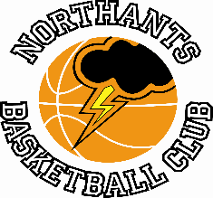

PRESS RELEASE & NEWSLETTER

Three teams from the Club in YBL Finals action last weekend with success for two but disappointment for the Under 11’s

“Lightning” Under 11 Girls are YBL Champions

YBL Under 11 Girls Final
Northants “Lightning” 59 - 40 Nuneaton “Predators”

On the back of 16 points from Gracie Barrett and an excellent defensive performance the Northants “Lightning” Under 11 Girls retained the Under 11 Girls YBL title for the Northants club.

Nuneaton fielded just six players allowing them to keep strong players on the court for the whole game while under the ‘all must play rule’, “Lightning” would have to play all nine of their roster.

The first quarter was a cagey affair with both teams managing just six points. The game was broken open in the second quarter which “Lightning” won by 24 points to four, Barrett contributing 14 of those points. “Predators” were much more competitive in the third quarter but some determined defence and excellent rebounding from Samanta Sudeikyte gave “Lightning” the edge 16-12 and a 46-22 lead going into the final stanza.

Nuneaton won the final quarter 18-13 but never seriously threatened the “Lightning” lead as they ran out winners by 19 points. In addition to Barrett’s 16 point contribution Myla Riley scored 12 points, sister Amelia eight and team captain Urte Maldutyte capped an excellent all-round performance with nine points.

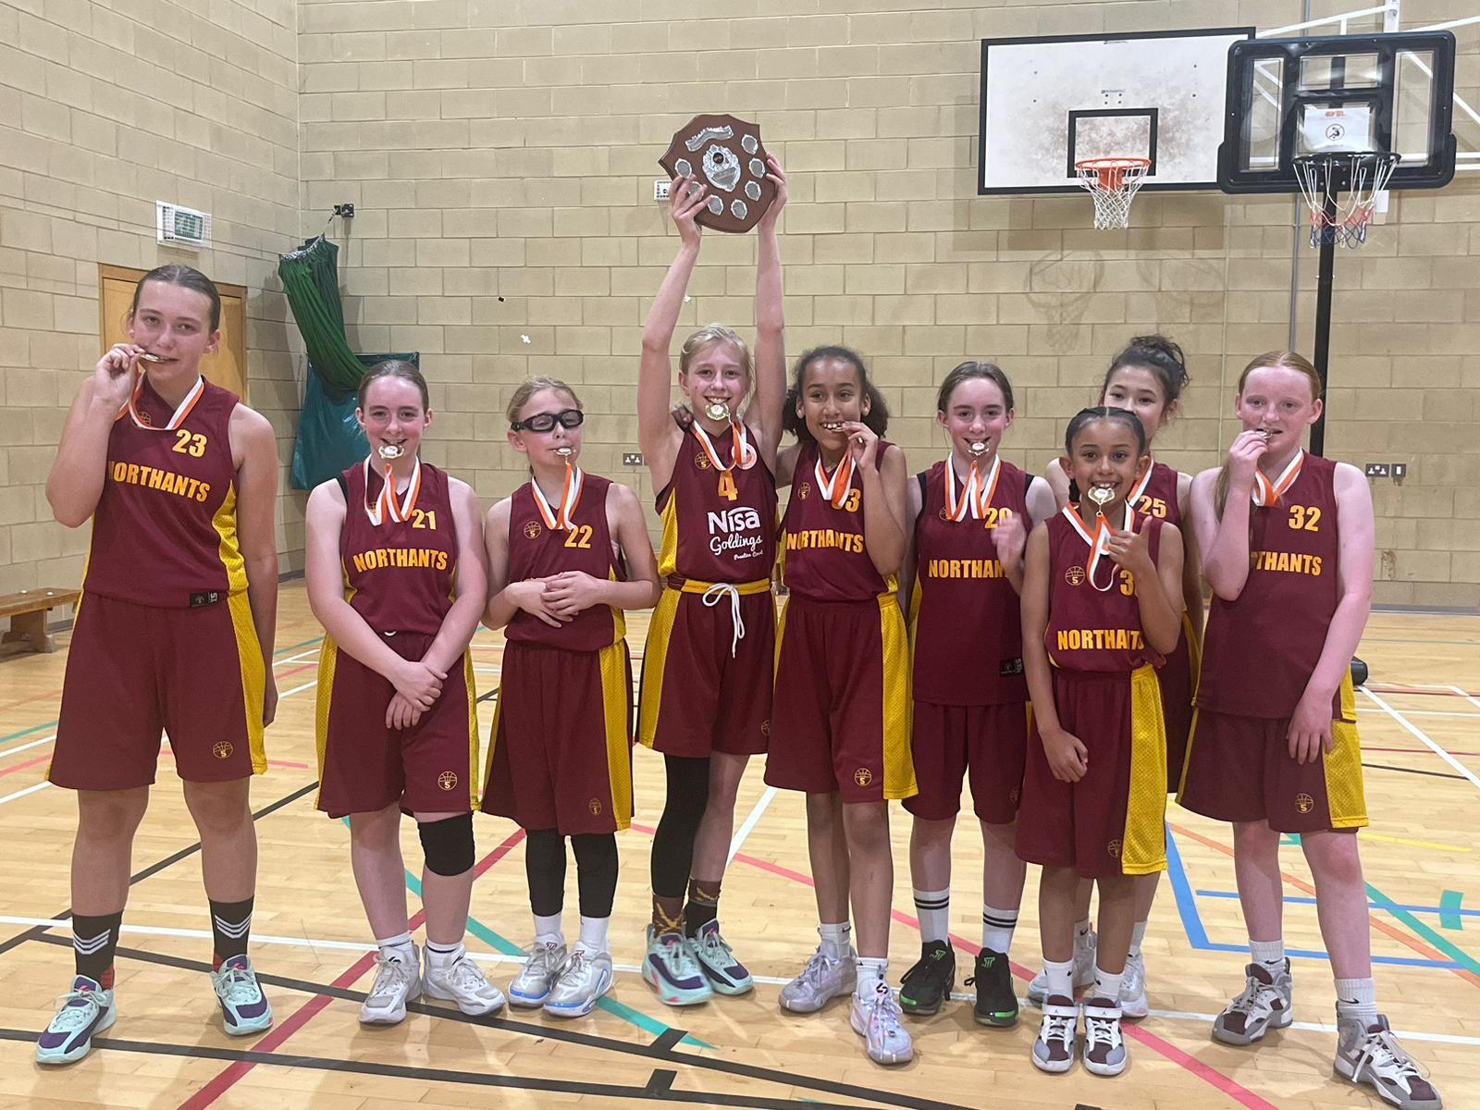

“Lightning” Under 11 Girls – 2024 YBL Champions

“Storm” Under 11’s win the games but aren’t winners

YBL Under 11 Mixed Semi Final
Northants “Storm” 88 – 18 “Rawzone”

Against the unknown quantity that was “Rawzone”, the Northants “Storm” Under 11’s turned in a dazzling performance totally dominating the game and winning by a massive 70 point margin. All ten “Storm” players contributed to the final points total led in scoring by Ernie Windrum and Kyjah Adams with 23 and 14 points respectively.

In the break before the Final, “Storm’s” opponents Coventry “Tornadoes” put in a protest that some of the Northants players held national league licences. This rule change had been introduced at the start of the 2023 / ’24 season and had been missed because of an administrative error.

Four “Storm” players have been playing in the National League albeit for an older age group but technically they should not have been playing in the YBL competition.

Coventry “Tornadoes” 69 – 55 Northants “Storm”

With the Final decided on a technicality the game between “Storm” and “Tornadoes” still went ahead, Coach Emma Salisbury gave all her players ample playing time, and “Storm” beat the ‘champions’ by fourteen points to maintain their unbeaten season record.

“Storm” Under 9’s hold on to take the title

YBL Under 9 Mixed Semi Final
City of Birmingham “Rockets” 22 – 32 Northants “Storm”

The unbeaten “Storm” Under 9’s took on City of Birmingham “Rockets” in this semi-final and thanks to an excellent first quarter and a resilient second half beat them by ten points.

Quite amazingly C.O.B. from a major conurbation and with less distance to travel turned up with just seven players. All ten of the “Storm” team gave of their all and thanks to eight points from Ezra Kuranchie had established a 16-six half time advantage. This lead was extended to 24-12 by the end of the third quarter thanks to six points from Nevaeh Cox and despite losing the final quarter 8-10 “Storm” held on for the win.

YBL Under 9 Mixed Final
Northants “Storm” 24 – 22 Worcester “Wolves”

“Wolves” had been involved in a close semi final against Coventry “Tornadoes” and proved to be extremely tough opponents as they edged an attritional first quarter 4-2. Point scoring was at a premium in the second quarter as well “Storm” winning it 4-3 to lead 7-6 at half time.

The third quarter became increasingly physical, and this seemed to suit “Wolves” who won the quarter 11-7 to establish an 18-13 lead going into the final stanza. Needing to show determination beyond their years and thanks to vital scores from Kobe Petty and Ezra Kuranchie allied to a number of missed free throws by “Wolves”, “Storm” won the quarter 11- four and the game by 24 points to 22 to become YBL Champions.

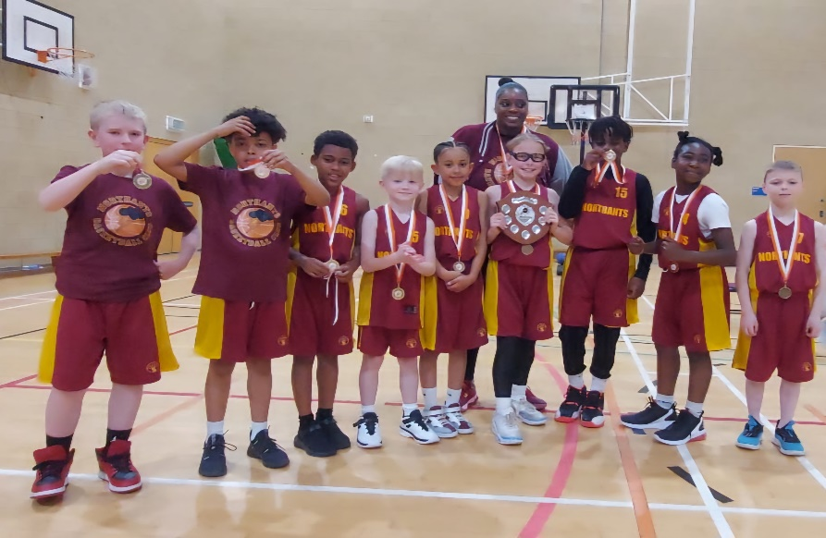

Northants “Storm” Under 9’s with Coach Corinne Douglas – 2024 YBL Champions

THIS WEEKEND’S ACTIVITIES

Saturday 1st June and Sunday 2nd June
No “Ballers”, “Slam Jam” or Community sessions.

Saturday 1st June
9-45am “Thunder” Under 13’s versus West Brom Basketball
(YBL Play Off Final)

11-55am “Lightning” Under 13’s versus Nuneaton “Predators”
(YBL Play Off Final)

2-00pm “Lightning” Under 17’s versus Abingdon “Eagles”
(YBL Play Off Final)

Sunday 2nd June
12-15pm “Thunder” Under 15’s versus Leicester “Riders”
(YBL Play Off Final)

The YBL Play Off Finals will be played at Bromsgrove School

For further information about this Press Release contact John Collins on +44 7801 533 151

