NORTHANTS BASKETBALL CLUB

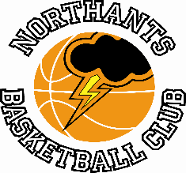

PRESS RELEASE & NEWSLETTER

Regional Award for Karen Goodrich

Northants Basketball Club and Northampton School for Girls coach Karen Goodrich has been given the
2023 “All Girls” Inspiring Female Award for the East Midlands.

In her two roles Karen a former National League and national team player has championed girls’ basketball for several years with considerable success. Currently there are over 100 active female players in the basketball club and 80 girls in competitive teams at N.S.G. plus 40 attending casual sessions.

In addition to working with players Goodrich also runs a Young Leaders course at N.S.G.

Karen’s philosophy and approach to encouraging girls to play are simple, “I gained so much from playing basketball and I just want to give girls the same opportunities I enjoyed. I think it is important that at club and at school girls are given the opportunity to play basketball at both an elite and casual level. The benefits are enormous.

The citation from Basketball England read, “I can’t think of a more deserving woman than you to receive this award; you have inspired more young women to play basketball than you will ever know. Thank you!!”
As winner of the regional award Karen’s name will go forward for consideration for the national Inspiring Female Award.

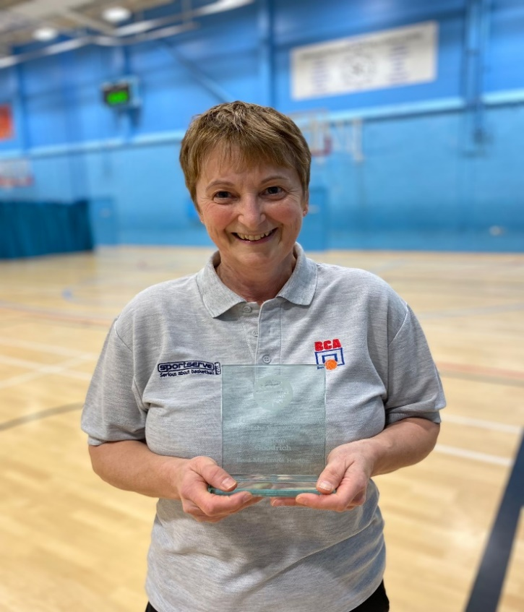

Karen Goodrich with her Basketball England “All Girls” Inspiring Female Award
for the East Midlands
Benas leads Junior Men to the double over “Titans”

Junior Men’s NBL Midland 2 Conference
Northamptonshire “Titans” 69 – 78 OEH Northants “Thunder”

Playing his final game for the Northants Club, guard Benas Maldutis poured in 31 points to help “Thunder” to victory over Northamptonshire “Titans” and complete the double over their local rivals.

“Titans” made the better start to the game, but a late surge saw “Thunder” edge ahead 22-19 after the first quarter. Both teams struggled to score in the second quarter but thanks to nine points from Maldutis “Thunder” were able to take the quarter 16-12 to extend their lead to 38 points to 31 by half time.

The game was blown open in the third quarter when rushed offences combined with a failure to protect their backcourt by “Titans” saw “Thunder” run in a numerous fast breaks one of them from a massive 30 meter ‘assist from Rapolas Radavicius. “Thunder” won the quarter 21-seven and at 59-38 the game was as good as over.

“Titans” resorted to a more direct style of attack in the final quarter and it proved to be very effective and Radavicius fouled out of the game some “Thunder” nerves were on edge. “Titans” poured in an impressive 31 points in the quarter but some key scores from Maldutis and an unlikely three-pointer from Elias James kept “Thunder” in front as they ran out winners by 78 points to 69.

In the nine points win only James and Danielius Jokulis could score in double figures to support Maldutis while for “Titans” former “Thunder” player Thoams Bates scored 18 points for “Titans”.

‘Oliwerless’ “Thunder Too” go down to “Rockets”

Under 16 Boys NBL Midland 1 Conference
Northants “Thunder Too” 52 - 68 City of Birmingham “Rockets”

Battling hard to gain a revenge win over City of Birmingham “Rockets” following a heavy defeat in Birmingham earlier in the season, “Thunder Too” suffered a major setback when their leading rebounder Oliwer Andrzejczak picked up a serious thigh injury and was forced out of the game. At that stage “Thunder Too” were holding a narrow lead but against the physically superior “Rockets” they faced an uphill battle.

The home side had contained “Rockets” in the first half of the game using change-up defences to confuse their opponents while attacking with some impressive fast breaks.

Leading 30-28 at half time “Thunder Too” were hit with a 14-4 C.O.B. run but responded with an 11-zero run of their own to take a 45 to 42 lead into the final minute of the third quarter. At this stage their cause was further handicapped by and injury to Logan Tanner and that saw the end of their challenge. In the remaining minute of the third quarter and the whole of the fourth they could only manage a further seven points finally slipping to a 52 points to 65 defeat.

In the disappointing loss the “Thunder Too” scoring was led by Anton Kelly with J.J. Lothian, Andrzejczak and Tanner, before their injuries all scoring ten points.

This season “Thunder Too” have played a year young in the Under 16 Midland 1 conference finishing in a very creditable mid-table position.

Under 12 Mixed NBL League Region II
Sheffield “Blue” 20 – 0 Northants “Storm Too”

Non-availability of the “Storm Too” coach meant that reluctantly the game had to be conceded to Sheffield.

Superb overtime comeback win for Under 14 Girls II
D
East of England Under 14 Girls Regional League
Southend “Scorpions” 78 – 80 Northants “Lightning Too”
(70-70)

The Northants “Lightning Too” Under 14 Girls recorded an amazing overtime win against a Southend “Scorpions” team packed with national league players.

After the long journey to Southend the Northants girls made a sluggish start to the game and found themselves trailing 14-25 after the first quarter. During that first quarter “Lightning Too” had been hurt by “Scorpions” pick & Roll offence and this continued in the second quarter. A brace of three-pointers from Freya Tauber-Anderson helped “Lightning Too” to edge the second quarter 19-18 but the team was still trailing by ten points at half time.

Needing a good start to the third quarter the Northants girls were guilty of some sloppy offensive play leading to needless losses. A time out by Coach Adam Latimer and some stern word got the team back on track and thanks to some crucial scores from Macie Latimer got her team back to within four points of their opponents. They then conceded three baskets before Latimer scored a three-point buzzer beater from inside her own half.

This morale boosting score seemed to galvanise the “Lightning Too” players and despite trailing 50-58 going into the final ten minutes of play the momentum was with them. As the game was drawing to a close “Scorpions” were still ahead by seven points but a combination of excellent individual defence from Nadia Boneza and some pressure defence from the rest of her team saw “Lightning Too” score eight points to take the lead for the first time since the opening minute of the game. “Scorpions” were able to convert a free throw to tie the scores at 70 points all and the game went into overtime.

In a nervous period of overtime Tauber-Anderson cooly converted two free throws and a Latimer jumper gave “Lightning Too” a four point advantage with forty seconds of the game remaining. The Northants girls were unable to add to their total in that final forty seconds but their determined defence kept Southend to just one basket as they held on for a remarkable win.

The “Lightning Too” scoring was dominated by Boneza, Tauber-Anderson and Latimer who scored a staggering 45 points, but Coach Latimer was quick to draw attention to the tremendous effort of all twelve players in his team.

“Lightning” dominate latest Rose of the Shires Tournament

Rose of the Shires Under 11 Girls League

Duston “Hawks” 21 – 13 Northants “Lightning Too”
Bedford “Thunder” 21 – 18 Northants “Lightning Too”

Duston “Hawks” 2 – 13 Northants “Lightning”
Kettering “Phoenix” 8 – 18 Northants “Lightning”

Superb defence earned Northants “Lightning” two wins in the latest Rose of the Shires tournament held at the University of Northampton last Sunday. In the game against Kettering Gracie Barrett scored ten points.

“Storm Too” were all the age of nine and they put in two excellent performances against girls two years their senior with Neveah Cox looking very impressive.

Under 11’s and Under 9’s look impressive against Tamworth

Under 11 and Under 9 Challenge Games
Under 11’s
Northants “Storm” 32 – 4 Tamworth “Tigers”

Northants “Storm” 21 – 28 Northants “Storm Too”

Northants “Storm Too” 43 – 18 Tamworth “Tigers”

Under 9’s
Northants “Storm” 27 – 23 Northants “Storm Too”

Northants “Storm” 27 – 17 Tamworth “Tigers”

Northants “Storm Too” 22 – 11 Tamworth “Tigers”

The youngest players in the Northants Club played some excellent basketball in defeating a Tamworth “Tigers” and then played competitive games against the team from their own club.

“Ballers” and Community Groups Awards

Last Saturday certificates and awards were presented to boys and girls in the “Ballers”, “Junior Ballers” and Community Groups. The winners were:

Budding Ballers (Years Reception, 1 & 2): Raelle, Freya and Kirell
Junior Ballers (Years 3 & 4): Vinnie and Joe

Under 12 Community (Years 5 & 6): Amos, Harley and Ranell
Year 7): Chance and Jensen
Under 14 Community Group (Year 8): Joshua
(Year 9): Emmanuel

THIS WEEKEND’S ACTIVITIES

Saturday 30th and Sunday 31st March

As it Easter weekend there will be no “Ballers” activities or games at the Basketball Centre.

The Club is running a Camp during the daytime on Wednesday and Thursday 3rd and 4th April and the following week on Wednesday 10th and Thursday 11th April.

Full details and an application form can be found in the WhatsApp group of your child.

For further information about this Press Release contact John Collins on +44 7801 533 151

