NORTHANTS BASKETBALL CLUB

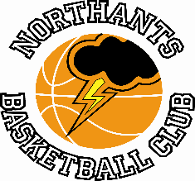

PRESS RELEASE & NEWSLETTER

A massive tally of thirteen games for teams from the Northants Basketball Club last weekend with just one loss

Junior Men’s NBL Midland 2 Conference
EOS Northants “Thunder 20 – 0 Stourport “Spartans”

The disappointing run of cancellations for the “Thunder” Junior Men continued last Saturday with Stourport unable to field a team. The game was awarded to “Thunder” 20 – zero.

Cadet Boys beat the Champions

Under 16 Boys NBL Midland 1 Conference
Northants “Thunder” 64 – 61 Warwickshire “Hawks”

The projection was that this game would decide the destination of the Midland 1 Conference title but “Thunder’s” loss to ‘Big Sky’ West Bromwich had handed the tile to “Hawks”. “Thunder” were keen to clinch a win over the Conference champions and if possible, win by more than the five points they had lost to “Hawks” just before Christmas.

In the event they achieved one of those objectives by winning Sunday’s game, but they could only manage a three point margin after missing two free throws in the dying moments of the game.

“Thunder” made a slow start to the game but then hit their opponents with a 9-3 and 10-2 runs to take a 21-16 lead after the first quarter. The home side maintained their advantage for the first half of the second quarter but their scoring totally dried up over the last three minutes of the quarter. “Hawks” took the quarter 16-10 to take a 32-31 half time lead but “Thunder” had shown enough to feel confident about the outcome of the contest.

“Thunder” went toe to toe with the Conference champions for seven minutes of the third quarter with Fran Guei causing “Hawks” a lot of problems close to the basket. Trailing 43-48 with three minutes of the quarter remaining, “Thunder” hit “Hawks” with a ‘trapping’ zone defence which forced a number of turn-overs leading to early scores. “Thunder” went on a 12-zero charge to take a 55-48 lead which they were to hold until the end of the game.

The final quarter was an attritional affair won 13-9 by “Hawks”, “Thunder” holding on for a well-deserved revenge win.

In the three point triumph Guei top scored with 25 points with excellent support coming from Harry Dutton and Logan Ormshaw with 14 and 12 points respectively.

At the end of the game the two teams posed together for the photograph below.

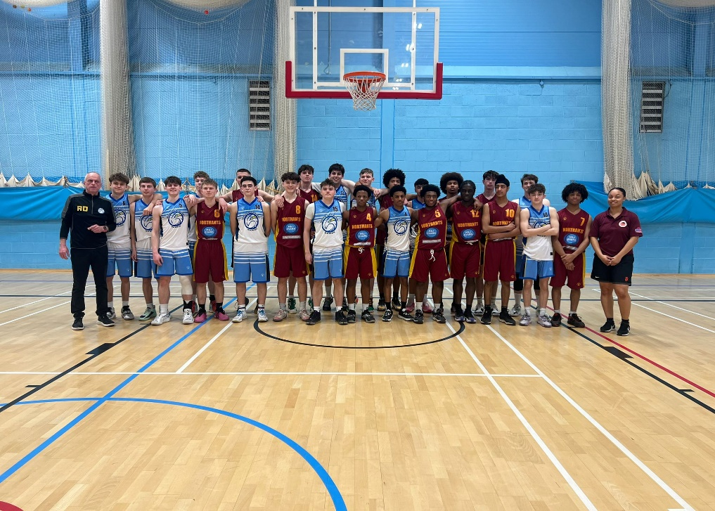

Midlands Under 16 Midland Conference champions Warwickshire “Hawks”
with runners up Northants “Thunder”

Cadette girls too strong for Kettering

Under 16 Girls Midlands Conference
Northants “Lightning” 83 – 37 Kettering “Phoenix”

The “Lightning” Under 16 Girls closed their Midlands Conference season with an emphatic victory over local rivals Kettering “Phoenix”. With some games still to be played it loos as if the team will come fourth in the Conference after making a significant improvement since Christmas.

The game was over as a contest by half time with “lightning” holding a 52 points to nine lead. To their credit the Kettering girls battled hard in the second half only losing it 31-28.

In the comfortable win the “Lightning” scoring was led by Jenny Oamen with a massive 33 point haul good support coming from Amelia Wesley-Maryan and Iviannah Meadows with 15 and 12 points respectively
Joy and sorry for “Thunder” Under 15 Boys

Under 16 Boys NBL Midland 1 Conference
Northants “Thunder Too” 78 - 65 Ballers Heaven “Warriors”

The Northants Under 15 Boys gained revenge for the five point defeat they had suffered at the hands of Ballers Heaven just before Christmas.

“Thunder Too” put together an excellent first quarter of team basketball with no less than seven players contributing to the scoring as they took a 27-15 lead after the first ten minutes of play. The Northants outfit were helped by “Warriors” inability to convert free throws in the second quarter and were able to edge the quarter 18-16 to take a 45-31 half time lead.

Early in the third quarter “Warriors” played some excellent basketball and outscored “Thunder Too” 9-4 to close the gap to nine points but they were also in foul trouble and this seriously affected their offensive rhythm and defensive effort. “Thunder Too” rallied with an 11-zero scoring charge to win the quarter 15-9 and take a 60-49 lead into the final stanza.

The fourth quarter saw four “Warriors” players fouling out of the game and “Thunder Too” eased home by 78 points to 55 led by high scorers Oliwer Andrzejczak , J.J. Lothian and Logan Tanner who all had double figure tallies.
Buzzer beating ‘three’ and poor clock management leads to shock loss

YBL Under 15 Boys Primis
Northants “Thunder Too” 80 – 81 Birmingham “Bears”

Two three-pointers from “Bears” ‘streak’ shooter Bird landed the Birmingham team an unexpected victory after they had trailed by as many as 21 points midway through the third quarter. At this stage a tired looking “Thunder” outfit leaked 18 points whilst scoring just four points themselves. The fourth quarter of play saw “Thunder” miss eight free throws but leading 76-65 with just four minutes of the game remaining they still looked favorites to win the game. In those final four minutes “Thunder” were guilty of some appalling ‘clock management’ taking a number of rushed shots when possession of the ball was more important.

For twenty-five minutes of the contest “Thunder” had looked a class act against a “Bears” team who had a significant height advantage. The home side won the first quarter 27-15 and the second 18-12 before the alarming third quarter collapse and the poor decision making late in the game.

In the disappointing defeat the “Thunder” scoring was led by Oliwer Andrzejczak and Logan Tanner with 21 and 18 points respectively Anton Kelly and Will Carr also making significant contributions.

Under 14 Boys are Midlands Conference Champions

Under 14 Boys NBL Midlands Conference
Northants “Thunder” 97 – 80 Tamworth “Tigers

The Northants Under 14 Boys put pay to any speculation about the outcome of the Midlands Conference title with a comfortable win over Tamworth “Tigers” in a high scoring game.

When the two teams had met earlier in the season in Tamworth, “Thunder” had cruised to a comfortable thirty plus points win but “Tigers” were a much more competitive outfit last Saturday and were only trailing 18-19 going into the final two minutes of the first quarter. They were then well and truly “Kellyed” as the “thunder” forward scored eight points to give his side a 29-18 lead.

“Tigers” were competitive for the rest of the game winning the second quarter 20-19 despite missing ten free throws. “Thunder” edged the final two quarters with Luca Garratt looking impressive as they close out the win by 97 points to 80 led by 26 points from Anton Kelly and 25 from Garratt; Joelle Stiete-French and Al Mustafa Yinusu with 13 and 10 points respectively.

“Lightning” Under 14 Girls see off “Wildcats”

Under 14 Girls Midlands Conference
Nottingham “Wildcats” 68 – 76 Northants “Lightning”

Champions elect Northants “Lightning” completed their Conference season with an eight point win over Mottingham “Wildcats” last Sunday.

“Lightning” opened the game at a blistering pace jumping out to a 24-8 first quarter lead. “Wildcats” mounted a determined fight back in the third quarter which they won 20-11 to close the gap to 35-28 by half time.

“Lightning” were ‘more of their usual selves’ in the third quarter and their pressing defence helped them to open up a twenty point lead at 63-43 by the end of the third quarter. With Coach Mark Spatcher making numerous rotations in his line up “Wildcats” were able to dominate the final quarter which they won 25-13 without seriously threatening the final outcome.

In the eight point win the “Lightning” scoring was led by Campbell with 28 poits, Macie Latimer contributing 16 points.

Dramatic end sees “Lightning Too” complete the double

East of England Under 14 Girls Regional League
Braintree “Blue Devils” 20 – 44 Northants “Lightning “Too”

Northants “Lightning Too” 46 – 45 Southend “Scorpions”

After comfortably beating a much improved Braintree team with some excellent team basketball; “Lightning Too” locked horns with a Southend “Scorpions” team stacked with national league payers.

As in their first game good team offence combined with determined defence “Lightning Too” were able to establish a 25-15 half time lead but they rather ‘hit the wall’ in the third quarter. Possibly tired after playing back-to-back game they could manage only three points in the third quarter “Scorpions” scoring 18 to take a 33-28 lead going into the final quarter.

Coach Adam Latimer urged his team to one last effort and his team responded well by restricting the scoring opportunities of “Scorpions” best player. “Lightning Too” were also able to score more freely and with a minute of the game remaining had established a seven point lead. Southend responded with two fast break baskets and an out of bounds play to reduce the Northants lead to a single point.

On the next play the ball was tied up with possession going to “Scorpions” with one point five seconds of the game remaining. Southend attempted to run their out of bounds play once again but the inbound pass was intercepted by Nadia Mereza and the victory went to “Lightning Too”

Under 13’s complete double over “Eagles”

Under 13 YBL Mixed Group ‘D’
Northants “Thunder” 80 – 29 Abingdon “Eagles”

Despite a slightly below par performance the Northants Under 13’s were able to complete the ‘double’ over a keen and determined Abingdon “Eagles” closing out the regular season with an unbeaten record going into the Play Offs.

“Thunder” were without three players who were in action with the club’s Under 12 team so drafted in three players from the “Lightning” squad and those three girls made significant contributions to the comfortable win.

The “Thunder” victory was based on their stifling defence which forced numerous “Eagles” turn-overs and easy scores but their half court offence was far from efficient.

In the comfortable win Sam Dominici top scored with 24 points, Alex Rados and Freya Tuaber-Anderson supporting well with ten point hauls.

Amazing weekend for Under 12 Boys

The Northants “Storm” Under 12 team completed an unbeaten season with a brace of wins over the weekend the first clinching the Region III title.

Under 12 Mixed NBL Region III
Warwickshire “Hawks” 47 – 59 Northants “Storm”

The Northants “Storm” Under 12’s travelled to the depths of Warwickshire knowing that a win over “Hawks” would secure the Region III Conference title and take the pressure off them when they travelled to second placed Tamworth “Tigers” the following day.

On the back of 19 points from Daniel Kevalevskij, “Storm” turned in an efficient performance to take the game by 12 points against a much improved “Hawks” team. “Storm” dominated the first quarter winning it by 20 points to eight but their scoring dried up in the second quarter which “Hawks” won 15-eight to close the gap to 28-23 at half time.

With nerves jangling little in the “Storm” camp and their scoring drying up in the home side edged third quarter 17-16 and with “Storm” only holding a four point advantage at 44-40 there was everything to play for in the last ten minutes of play.

Sensing the importance of the last stanza “Storm” turned in an impressive defensive performance restricting “Hawks” to just seven points whilst scoring 15 themselves to take the low scoring game by 59 points to 47.

Tamworth “Tigers” 37 - 74 Northants “Storm”

With the Conference title under their belts the team travelled to Tamworth the following day to take on a “Tigers” team they had beaten by just three points just before Christmas.

There was to be no repeat of that close game as “Storm” playing with freedom stormed into a 23-10 lead after the first quarter. “Storm” continued hard-nosed defence for the rest of the game restricting their opponents to just 27 points while scoring 51 themselves running out convincing winners by 74 points to 37.

In the impressive 37 points win ten of the “Storm” players scored led by Max Abraham with 21 points.

Under 12 Mixed NBL League Region II
Northants “Storm Too” 61 – 59 Leicester “Riders”

Earlier in the season “Storm Too” had suffered a heavy defeat at the hands of “Tigers” so this two point win is a very clear indication of how much the team has progressed throughout the season.

Thanks to a well-conceived defensive plan and some excellent fast break basketball “Storm Too” were able to tie the first quarter 14 all. The second ten minutes of play saw “Tigers” edge the quarter with “Storm Too” struggling to score but good defence kept them in the contest and they only trailed 25-29 at half time.

A far more confident “Storm Too” hit the court for the third quarter. They maintained their defensive intensity, but a flurry of fast break scores saw them open up a ten point led at 46-36 going into the fourth quarter.

The expected “Tigers” charge came in that final quarter and they were able to gradually close the gap but a Mark Spatcher three-pointer stemmed their run and despite losing the final quarter 15-23, “Storm Too” were able to hold out for the win.

In the narrow win Jack Thompson top scored for “Storm Too” with 17 points excellent support coming from Deev Patel, Fraser Lovitt and Edmund Thompson.

THIS WEEKEND’S ACTIVITIES

Saturday 23rd March
9-30am until 10-30am Budding “Ballers” and Junior “Ballers”
10-45am until 11-45am Ballers and Community Group End of Season Presentations

12-15pm until 4-00pm “Storm” and “Storm Too” Under 9’s
“Storm” and “Storm Too” Under 11 (Challenge games)
versus Tamworth “Tigers”
4-30pm Under 15 Boys versus C.O.B. Rockets II (NBL)

Under 14 Girls II travel to Southend “Scorpions” (ERL)
Under 16 Boys travel Leicester “Dynamite” (Challenge game)

Sunday 24th March
Junior Men travel to Northamptonshire “Titans” (NBL)
Game to be played at Moulton College
Under 12 Boys II travel to Sheffield “Blue” (NBL)
Under 11 Girls I and II play in a Rose of the Shires Tournament
at the University of Northampton

The “Ballers” activities and home games will take place at the Basketball Centre which is based
at Northampton School for Girls, Spinney Hill Road, Northampton NN3 6DG.

For further information about this Press Release contact John Collins on +44 7801 533 151

