NORTHANTS BASKETBALL CLUB

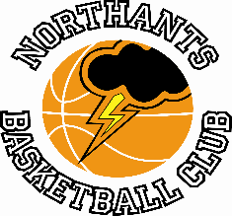

Season resumes this weekend.

The 2023 ’24 basketball season resumes for the Northants Basketball Club this weekend with four league games and one ‘friendly’ fixture, all of them away from home.

The Club will be hoping to build on a successful first half of the season which has seen no less than 13 of the club’s teams topping their league or Conference, ten of them with unbeaten records.

This season the Club is competing in four different competitions in order to give as many boys and girls as possible the opportunity to play competitive basketball. Those competitions are the National League run by Basketball England, the Your Basketball League, The Rose of the Shires League and The East of England League the last three run by independent organisations and volunteers. In addition to the competitive teams the Club runs two Casual sessions and the “Ballers” programme for under 8 boys and girls.

THIS WEEKEND’S ACTION

Saturday 6th January
OEH Group Junior Men travel to Milton Keynes “Breakers II”
Under 16 Boys travel to Derby “Trailblazers”
Under 14 Boys travel to Worcester “Wolves”

Sunday 7th January
Under 12 Boys travel to Stourport “Spartans”
Under 14 Girls travel to Manchester “Mystics for a ‘friendly’ game.

There are no “Ballers” activities or games at the Basketball Centre this coming weekend.

For further information on this Press Release contact:
John Collins on 07801 533 151

